**GSA AND AGI LAUNCHES 2019 INDUSTRY & QUALITY AWARDS**

**Date: 2019-06-17**

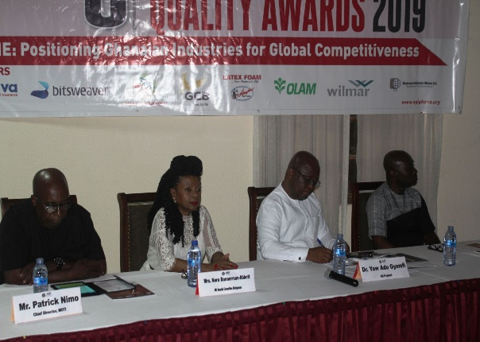The 8th edition of the AGI Industry and Quality Awards was successfully launched on Thursday, 7th June 2019 at the Coconut Grove Regency Hotel in Accra.

In attendance were industry players, members of AGI, sponsors and representatives of Award winners from last year’s edition. This year’s launch was graced by Chief Director of the Ministry of Trade and Industry, Mr. Patrick Nimo.

In his opening remarks, the President of AGI, Dr. Yaw Adu-Gyamfi, reiterated the need to reward the hard-working Ghanaian industries who are members of the AGI – the leading voice of the private sector in Ghana. He said, “the AGI Industry and Quality Awards is to reward exemplary and distinguished companies in their efforts at achieving excellence in their operations and maintaining standards. AGI would like to see a business environment where hard work is continuously rewarded and help is available for those who need it”.

On his part, the Chief Director, MOTI, Mr. Patrick Nimo, who represented the Honorable Minister, commended the AGI for instituting and sustaining the award scheme for the past eight years. He indicated the Ministry’s readiness to collaborate with the Association to make this year’s edition a bigger one.

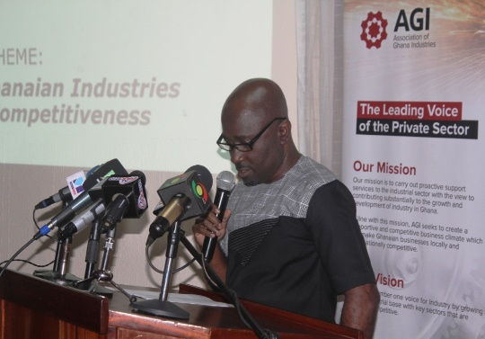In his remarks, Mr. Emmanuel Asare, representing the Director General, GSA, praised the AGI for the collaboration and inclusion of the National Quality Awards category in the annual AGI awards, which has become known as the AGI Industry and Quality Awards, since 2017. He encouraged and stressed the need for more of the small and medium-sized enterprises to take part in the 2019 edition and be recognized for upholding standards in their operations.

Nestle Ghana Limited is the current winner of the Overall Best Industrial Company of the year Overall National Best Quality Company and National Quality Award Diamond (Food Category), whilst Tropical Cable & Conductor Limited is the National Quality Award Diamond (Non-Food Category). Everpure Ghana Limited won the National Quality Award Gold (Category A).

This year’s award is under the theme “*Positioning Ghanaian Industries for Global Competitiveness***”** and will be held in November 2019.